**43rd Sem Mini Project Report on**



**BIKE TYPE RECOMMENDER**



**Submitted in partial fulfillment of the requirement for the award of the degree of**

**BACHELOR OF TECHNOLOGY**

**IN**

**COMPUTER SCIENCE & ENGINEERING (AI-DS)**

**Submitted by:**

**Student Name-** **ANSHUL RAUTHAN** **University Roll No.- 2318431**

***Under the Guidance of***

**Dr. Ajay Shukla**

**Department of Computer Science & Engineering**



**Department of Computer Science and Engineering**

**Graphic Era Hill University**

**Dehradun, Uttarakhand**

**2024-25**

**CANDIDATE’S DECLARATION**

I hereby certify that the work which is being presented in the project report entitled **“BIKE TYPE RECOMMENDER”** in partial fulfillment of the requirements for the award of the Degree of Bachelor of Technology in Computer Science and Engineering **(AI-DS)** in the Department of Computer Science and Engineering of the Graphic Era Hill University, Dehradun shall be carried out by the undersigned under the supervision of **DR. AJAY SHUKLA**, Department of Computer Science and Engineering, Graphic Era Hill University, Dehradun.

Name-ANSHUL RAUTHAN University Roll no- 2328431.

The above-mentioned student shall be working under the supervision of the undersigned on the **“BIKE TYPE RECOMMENDER”**

**Supervisor** **Head of the Department**

**Examination**

**Name of the Examiners: Signature with Date**

1.

2.

**Table of Contents**

|  |  |  |
| --- | --- | --- |
| **Chapter No.** | **Description** | **Page No.** |
| Chapter 1 | Introduction and Problem Statement | **5** |
| Chapter 2 | Methodology | **6** |
| Chapter 3 | Project Work Conducted | **8** |
| Chapter 4 | Results and Discussion | **9** |
| Chapter 5 | Conclusion and Future Work | **10** |
|  | References | **11** |

**I. CHAPTER 1**

**INTRODUCTION & PROBLEM STATEMENT**

**1.1 INTRODUCTION TO CYCLING**

Cycling is an activity that has gained high popularity worldwide, specially during the pandemic, a time when people started becoming more and more conscious about their health. In a country like ours, before the pandemic people recognised this activity widely as just a mode of transportation. But with its growing popularity, people have started to see its other benefits too. Let me tell you about the various ways a bicycle is used.

**1.2 CYCLING AS TRANSPORTATION**

In, India a ‘bike’ (professional term for a bicycle) is generally used by low- and middle-class workers to commute daily. The prime example will be the “ATLAS cycle”. (Shown in Fig. 1.1)

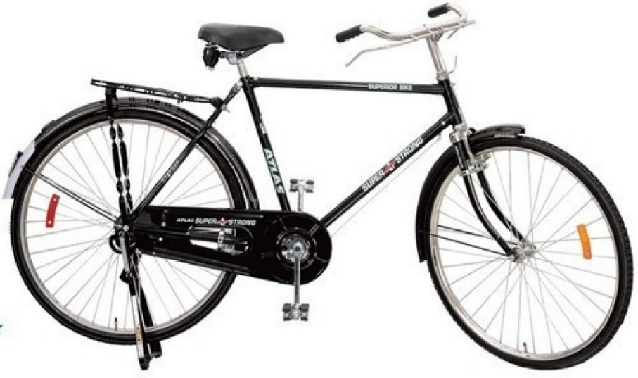

Figure .1 – ATLAS bicycle

**1.3 HEALTH & NATURE**

Cycling is also known as one of the best cardio exercises out there. Keeping your heart healthy and providing an almost full body exercise. Cycling improves blood circulation and helps in training leg muscles.

Cycling is also a very cost-effective and GREEN method of transportation. Unlike motor vehicles which run on fossil fuels and emit harmful gases, cycling has a very small carbon footprint.

**1.4 CYCLING AS A SPORT**

Believe it or not, cycling is a very recognised sport worldwide, with the most famous races being the “TOUR-DE FRANCE” which is an endurance road race, and the “RED BULL RAMPAGE” which is a downhill freestyle race event.

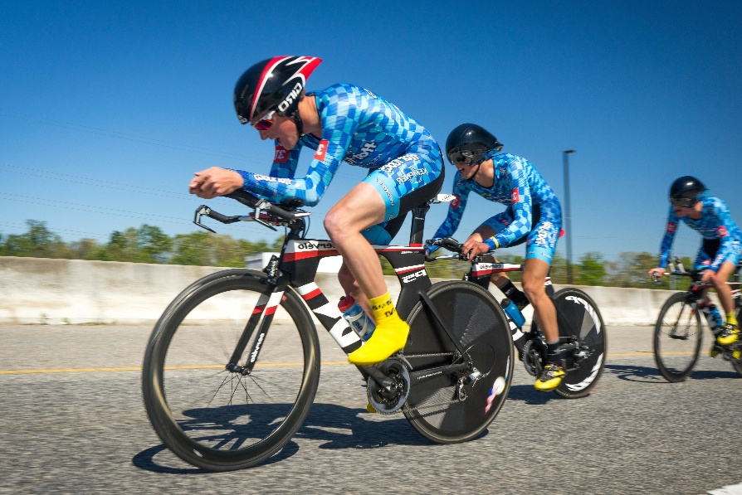

Figure 1.2 – TT racing

**1.5 NEED FOR A RECOMMENDER**

**1.5.1 Addressing the Challenge of Bike Selection**

The bicycle market encompasses diverse categories such as hybrid bikes, mountain bikes, road bikes, and gravel bikes, each tailored for specific terrains, preferences, and riding styles. For instance, hybrid bikes excel at commuting, mountain bikes dominate rugged terrains, road bikes appeal to speed enthusiasts, and gravel bikes blend road and mountain biking features. However, the variety in specifications, components, and price points makes selecting the ideal bike a daunting task for buyers.

Adding to the complexity are differences in user experience levels and budget constraints. Beginners may prioritize simplicity and affordability, while professionals seek advanced models tailored to specific needs. The challenge lies in balancing these diverse requirements effectively.

**1.5.2 The Bike Recommender System: A Solution**

To address these challenges, the **Bike Recommender System** was developed as a console-based mini-project. The system employs a structured, decision-tree approach to analyse user inputs—such as budget, usage, and experience levels—and recommends the most suitable bike category.

Key features include:

* **Personalized Recommendations**: Tailored bike suggestions based on user profiles.
* **Integrated Online Resources**: Curated links to explore recommended options conveniently.
* **User-Centric Design**: Simplifies decision-making for a satisfactory purchase experience.

This project bridges the gap between user needs and market offerings, providing an intuitive and efficient solution for navigating the complex bike selection process

‘The Bike Recommender’ model is not only a practical solution for buyers but also a demonstration of how computational tools can address real-world problems. It demonstrates the importance of user-centric design in technology, emphasizing the need for systems that adapt to individual preferences and constraints. As a mini project, it serves as a stepping stone toward more comprehensive and scalable solutions in the future.

In summary, this project aims to:

1. Simplify the process of selecting bicycles by leveraging a structured decision-making framework.
2. Provide recommendations tailored to individual budgets, experience levels, and intended usage.
3. Enhance user experience by offering direct access to online resources for exploring recommended options.
4. Lay the groundwork for future enhancements, such as dynamic data integration and advanced recommendation algorithms.

By addressing these objectives, the Bike Recommender System aspires to make bicycle selection a seamless and enjoyable experience for users of all backgrounds.

**II. CHAPTER 2**

**METHODOLOGY**

The development process of the Bike Recommender System was structured into distinct stages, each contributing to the creation of a user-friendly and effective solution for providing accurate bike recommendations.

**2.1. Requirement Analysis and Planning**

* **Objective:** Understand user needs, including cycling goals, budgets, and experience levels.
* **Approach:**
  + Compiled a list of bicycle categories (e.g., hybrid, mountain, road, gravel) and their characteristics.
  + Defined decision-tree logic to map user preferences to bike categories.

**2.2. System Design**

* **Design Principles:** Modular structure for scalability and maintainability.
* **Key Components:**
  + **User Input Module:** Collects user data (budget, experience, usage).
  + **Decision Logic Module:** Matches inputs to suitable bike categories via a decision tree.
  + **Web Integration Module:** Links users to relevant online stores.

**2.3. Development**

* **Implementation:** Built using C++ for efficiency in console-based applications.
* **Features:**
  + **Input Validation:** Ensures meaningful and valid user inputs.
  + **Dynamic Prompts:** Adapts questions based on prior inputs for refined recommendations.
  + **Online Resource Integration:** Uses the opensite function to open URLs for selected bikes.

**2.4. Testing and Debugging**

* **Testing Scope:** Covered diverse scenarios, including various budgets, experience levels, and usage cases.
* **Debugging:** Iterative process to resolve logical and runtime issues.

**2.5. User Experience Optimization**

* **Feedback:** Gathered from trial users to improve interaction clarity and flow.

**2.6. Deployment and Demonstration**

* **Deployment:** Released as a standalone console application.
* **Demonstration:** Showcased system capabilities by allowing users to interact with the application, receive tailored bike recommendations, and access online retailers.

**III. CHAPTER 3**

**PROJECT WORK CARRIED OUT**

**3.1 Data Collection and Categorization**:

* + Different types of bicycles were categorized based on features, usage, and price range. E.g.- MTB, ROAD, GRAVEL, FREESTYLE, HYBRID, etc
  + User data like budget, usage, commute distance and rider experience were taken into factor

Figure 3.1 – User data

* + Trusted sites are lined to the model that provide good service in case a user decides to buy a bike.

**3.2 Development**:

* + The model is implemented in C++.
  + Modular functions created for specific budget brackets and user experience levels.
  + External links are embedded using the ‘opensite’ function to direct users to relevant websites.
  + Usage of a “urls.h” header files that contains all the links to the websites, under the namespace ‘sites’.

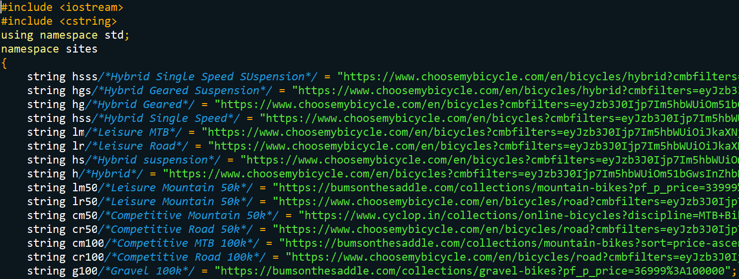

Figure 4.2 – “urls.h” header file

**3.3 Testing**:

* + Testing was carried out for various user scenarios (test cases), ensuring the logic flow correctly mapped inputs to appropriate recommendations.
  + Edge cases, such as invalid inputs or unusual combinations of preferences, are handled gracefully.

**IV. CHAPTER 4**

**RESULT & DISCUSSION**

The Bike Recommender System successfully demonstrated its capability to provide tailored recommendations. Key outcomes include:

* **User Engagement**: The interactive questioning approach kept users engaged, ensuring accurate capture of preferences.
* **Accuracy**: The system correctly identified suitable bicycle types for a wide range of budgets and preferences.
* **Usability**: The use of clear prompts and direct online links enhanced user experience.

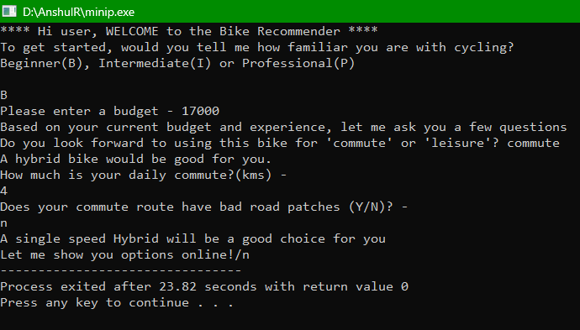

Figure 4.1 – Test Case

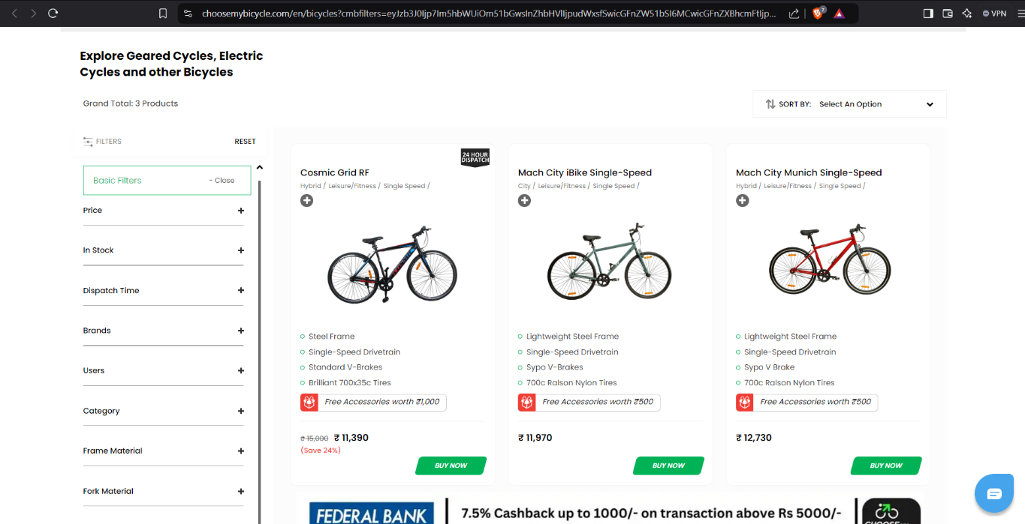

Figure 4.2 – Website opened by model

**V. CHAPTER 5**

**CONCLUSION & FUTURE WORK**

The Bike Recommender System is a functional prototype that effectively guides users toward suitable bicycle options. It bridges the gap between user preferences and market offerings by leveraging a structured decision-making process.

Future enhancements include:

1. **Cross-Platform Compatibility**:
   * Replacing the system command with a platform-independent library for opening URLs, for making the model cross-platform compatible.
2. **Dynamic Data Integration**:
   * Incorporating APIs from online bicycle retailers to provide real-time recommendations.
3. **User Interface**:
   * Developing a graphical user interface (GUI) for enhanced accessibility and visual appeal.
4. **Advanced Recommendations**:
   * Utilizing machine learning to improve recommendation accuracy based on user feedback and market trends.
5. **Update to budget brackets**:
   * Currently, the model has a very less amount of budget brackets to choose from, more budget brackets will be added to future updates.

**REFERENCES**

1. "C++ Programming Language" by Bjarne Stroustrup
2. Official documentation of the C++ Standard Library
3. Online resources and bicycle retailer websites used for product linking.
4. Categories of cycling helped by my fellow cyclists